|  |  |
| --- | --- |
| **Python** | **R** |
| lsdv_model = smf.ols(formula=lsdv_expr,data=df_with_dummies)  coef std err t P>|t|  ---------------------------------------------------------------------  Intercept -0.2749 2.027 -0.136 0.892  TA 1.8504 0.251 7.365 0.000  PA 1.2744 0.447 2.850 0.004  DL 0.0799 0.005 14.543 0.000    R-squared: 0.446  Adj. R-squared: 0.424 AIC = 42342.96 | AIC : 42344.96 |
|  | ok  with fixef() returns coeffs of admin1 and month  AIC : 42055.01 |
|  | AIC : 42039.76 |
| MAXIMUM LIKELIHOOD SPATIAL LAG PANEL - FIXED EFFECTS |  |
| MAXIMUM LIKELIHOOD SPATIAL ERROR PANEL - FIXED EFFECTS |  |

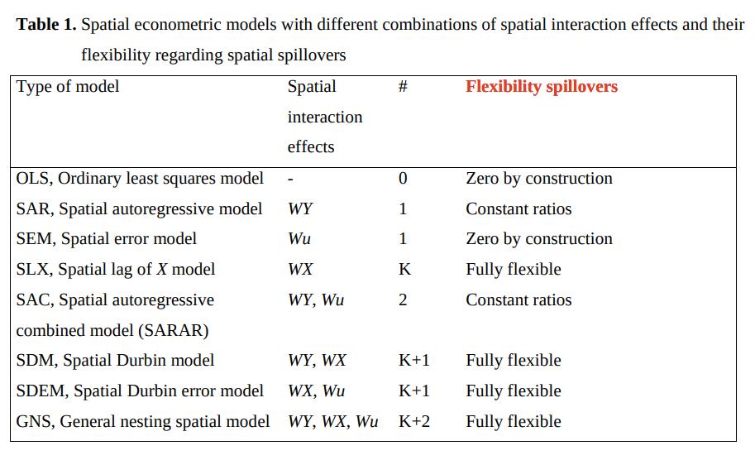

SAR (from 2016)

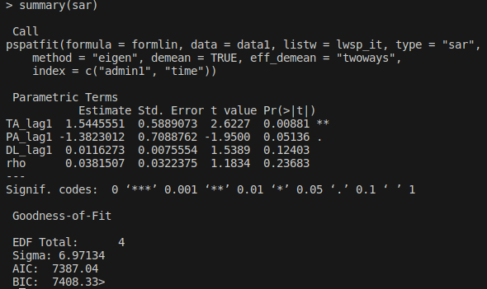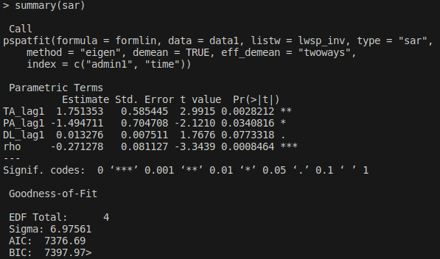

SEM

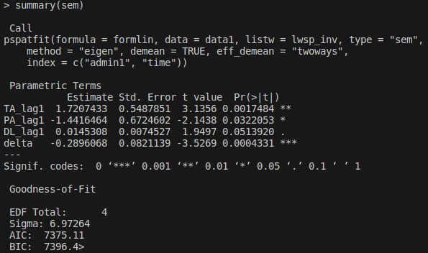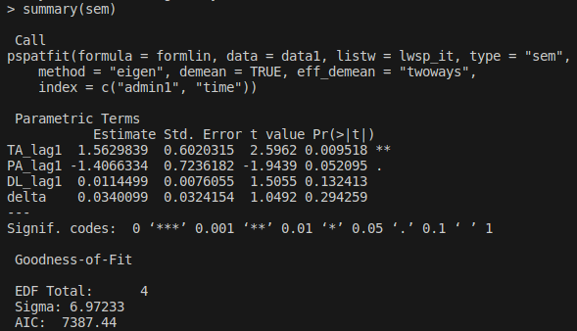

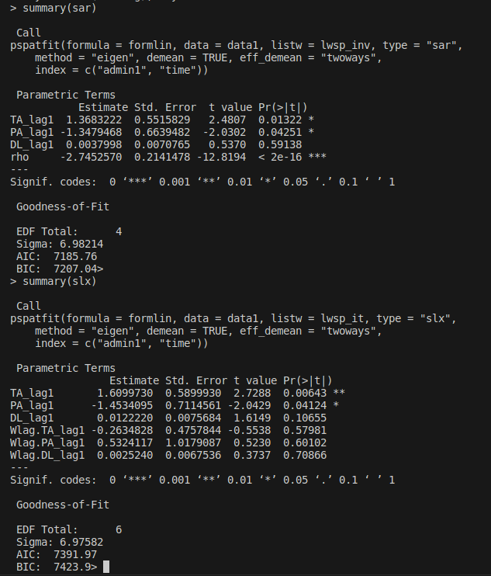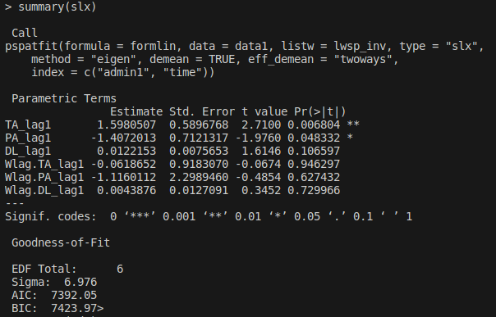SLX

SDM

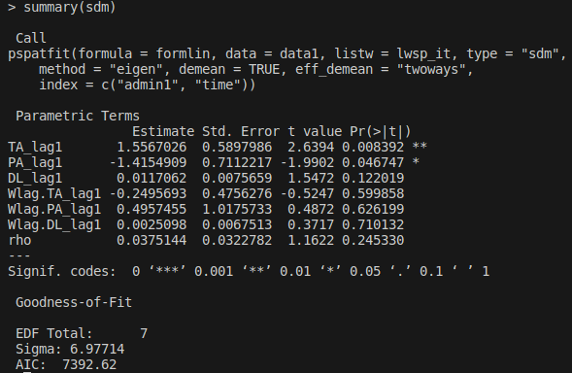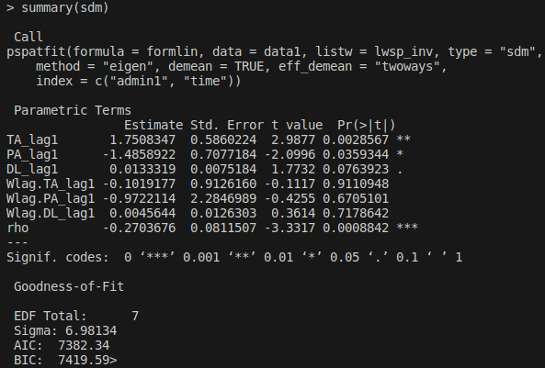

SARAR

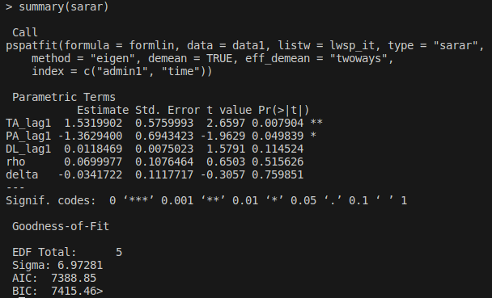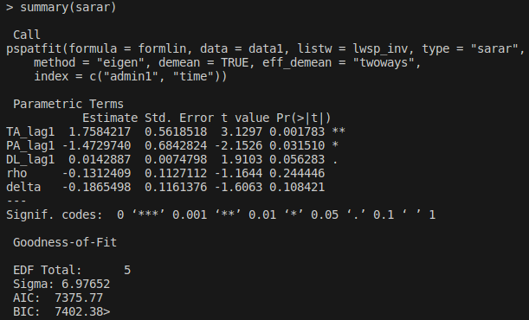

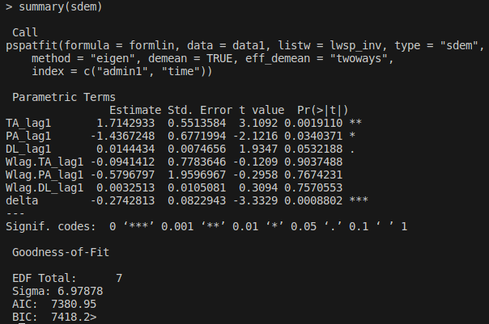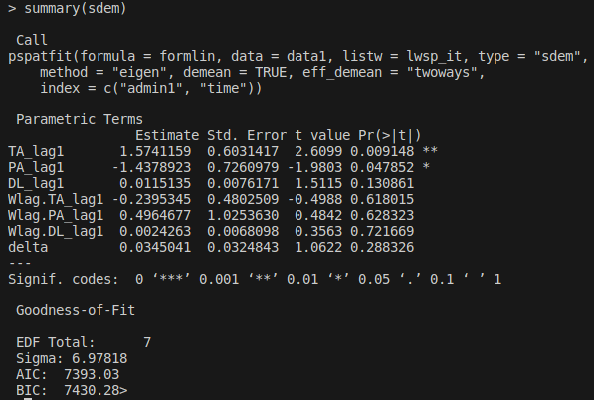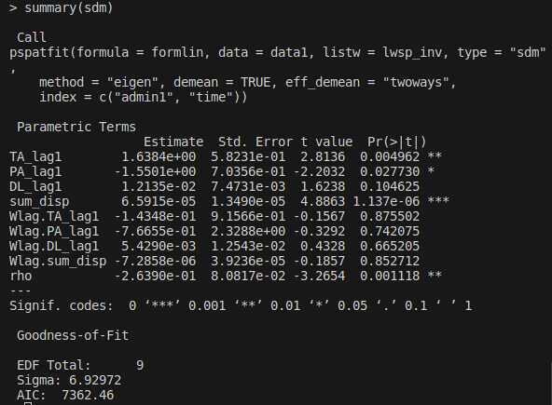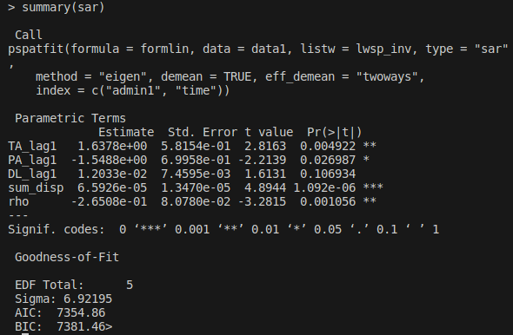SDEM

SAR + sum displacements

SDM + sum displacements